# Chirakara no Chikara (力の力)

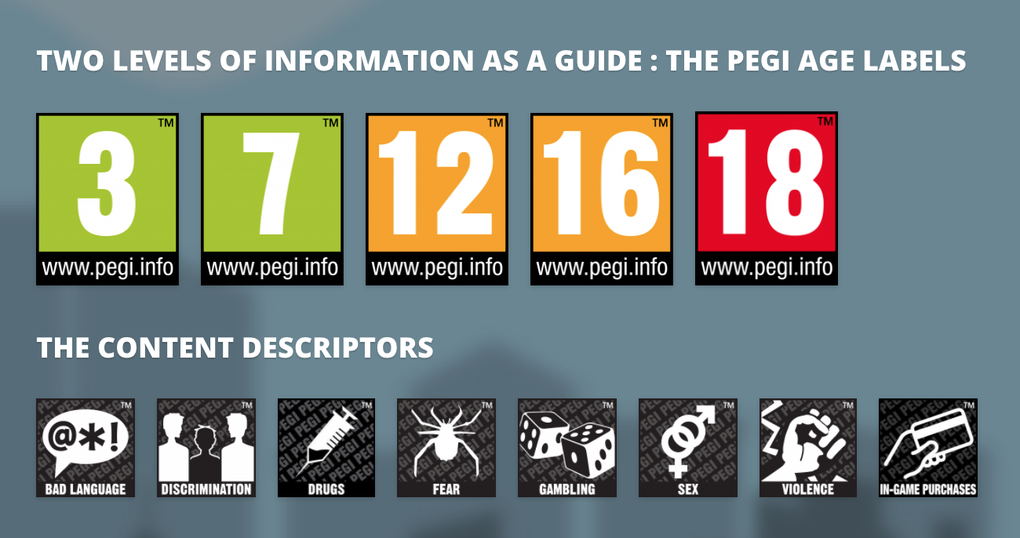 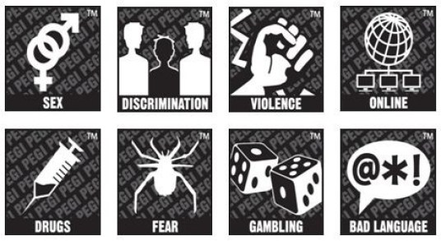  

Tagline – “SHROUD, Keep, Project, Express or Kill……”

### High Concept

In a mythical Japanese Anime style island, 100 players are pitted against each other and must use their magical powers to survive.

### Story

Chikara has existed since the creation of the universe. It dwells in all living things and binds matter together. The omni present force can and has been used consciously or unconsciously in a variety of ways by certain individuals such as athletes, magicians and geniuses. However, behind closed doors, only certain individuals have been able to control the flow of Chikara by opening and closing their nodes. Theses peoples are called Users. Users utilise Chikara in a variety of applications such as travel, hunting, mind tricks, and combat through 4 techniques. In the scope of this game, it is the magical power source the drives the plot.

Tamotsu – tis is ability to keep the flow of Chikara constant around the body without it escaping and in turn enveloping it around the user. This creates what appears to be a visible fog or cloud that can be seen around the user (only by other users.)

Teishsi – this is the ability to restrict the flow from leaving the body of from leaving the body altogether. This means the Chikara’s presence is greatly diminished from others to a certain extent. Masters of this ability can stop the flow completely to point that it is completely invisible even to the sensitive entities. This technique is very useful in covert applications or espionage were appearing like a civilian is key or guerrilla warfare.

Furō – this is the ability to quickly project the flow of Chikara outwards. This amplifies a user’s strength durability and the necessary power to use advanced Chikara techniques. However, due to furō being an inherently high every technique it can only be used for short bursts for a limited number of time as it drains the user’s stamina completely which can only be recharged through meditation or sleep. This makes this technique very valuable and should only be used in rare circumstances such as when the user is surrounded or needs the burst to finish off an opponent.

Tokkyū – this a personal expression of the release of Chikara. It depends on the skills and emotions of a user it hard to explain since it can carry out may different functions. In the scop of the story of the game it can simply be referred to as “Chi”

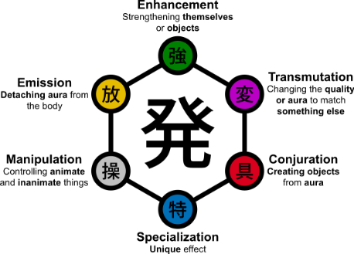All chi expressions can be placed into the following 6 categories:

1. Enhancers

Enhancers are simple honest and determined individuals. Theirs words and actions are typically governed by their feelings and desires and hence their Chi abilities reflect this. Enhancement is the ability to use their flow to increase the natural abilities of their own body or physical objects and even their healing powers. This means that they can greatly increase their physical attack and defence making them best suited for melee combat.

1. Emitters

Emitters are impatient, impulsive, inattentive and short-tempered characters they lack the ability to sit and wait and would rather react than wait and think. Their impulsivity creates for long range attacks. Emission id the ability to separate their flow from their body causing long lasting effects from range. This includes projecting out their chi in the form of objects and beams, even propelling oneself to even casting certain effects on another user from range.

1. Manipulators

Manipulators are logical yet argumentative and shifty individuals. They would rather use techniques to control other to achieve their own goals while keeping themselves and their families safe. They are slow to listen and would rather progress at their own pace. Manipulations is the ability control objects living or not. This means that they can control people to perform certain tasks or even to divulge certain information. Manipulators can even control other user’s chi abilities as they wish. They can pour their chin into any object usually relying on a medium such ass fog. This makes this ability highly feared in combat as once the manipulators chi comes in constant with the opponent the fight is pretty much over. Manipulators are also highly sought after in covert missions as they can use their chi to influence groups of people to doing as they wish will staying completely undetected. One of the main aspects of manipulations is mind control. This falls under the following.

* Solicitation – where they condition a victim into cooperating with their free will intact.
* coercion – where they take over the mind and body of a victim possessing complete control over them.
* pseudo coercion - where they only capture the body of a victim or place them in a scenario where they have no choice but the follow their commands.

1. Transmuters

Transmuters are uncertain whimsical and irresolute individuals and are regarded as outcasts due to their attitudes. However, this in only a mask to hide their true personalities and desires. Transmutations is the ability to change the properties or shape of their chi to mimic an attribute or something else entirely. Transmutations are made of pure chi and are often completely invisible to non-users. Due to the similarities in properties its usually mistaken for conjuration but due to the fact that that it only mimics certain properties of an object it cannot to change the chi to act as the certain object. For example, in lore Hisoke Morow’s “Bungee Gum possess both the qualities of rubber and gum.”

1. Conjurors

Conjurors are overly serious individuals and stoic individuals. However, they remain logical and on-guard making them difficult to trap and trick. Conjuration is the ability to materialise physical objects using their chi with their durability and strength being. They are overly attentive to detain nature means that they can conjure complex object such as whole building and object sometimes exceeding human expectations. These conjured objects can also have special abilities such as a vacuum cleaner that such infinitely suck up non-living or chi-made objects. One thing to note is that conjured objects can if wished would be perceived by non-users however they like all conjured objects disappear after 24 hours in lore (in the context of the game disappear quicker.)

1. Specialists

Specialists are divergent and independent characters. They a very reserved and do not make close friends. However due to their unique and alluring persona, they are often seen surrounded by people. Specialization is broadly defined by any chi ability that doesn’t fit in to the other 5 categories. This vague characteristic means its effect are usually wide rangeing.it is impossible to learn this chi type as it is though to have been present since birth.

The Island

The island is based on the greed island game in the HxH tv show. Greed island is a video game only played by Chikara users. The users Enter the game with their bodies and are teleported to the centre village of the island and are only released upon death victory or the acquiring of the leave card. The objective of this island is to compete with other users in direct combat utilising their chi powers if necessary. Out of the 100 players only 1 can be victorious. Other objectives include hunting for unique cards which possess certain chi abilities or testing their chi abilities on a user only island.

### Look and feel

The main screen features a 3D cartoon style open world rendition of a Japanese anime style village surrounded by a flat rolling landscape with acres of dense forestry. The 3rd person views of this game captures how a player should play this game giving them wider, more panoramic view that what a 1st person view would.

The screen in the corner of the screen shows where a player is located as well as relevant items and locations to the player

A

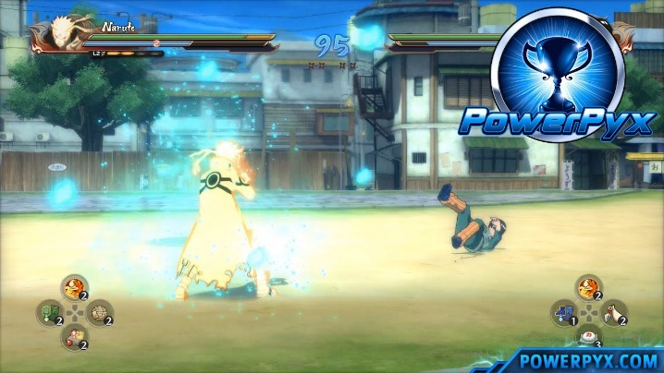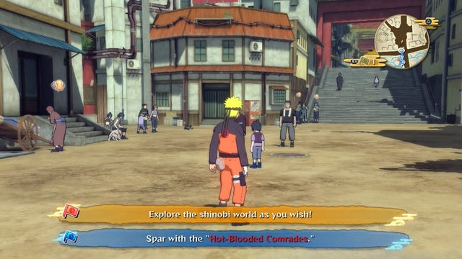

the camera depth should be similar to this game giving the player a far enough depth of view without giving away high rise or scaled attack as well as a health bar an mini-map

Example of what the field of view would look like in combat

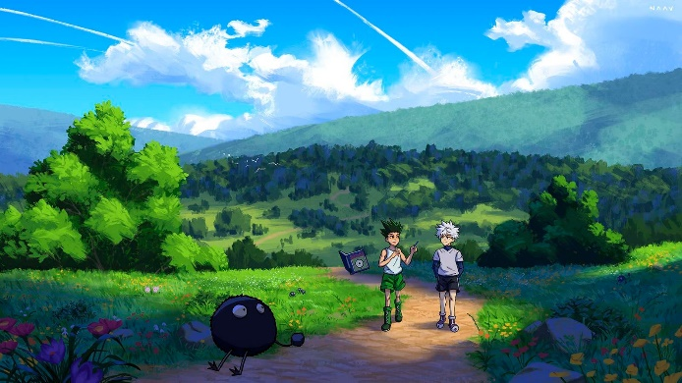

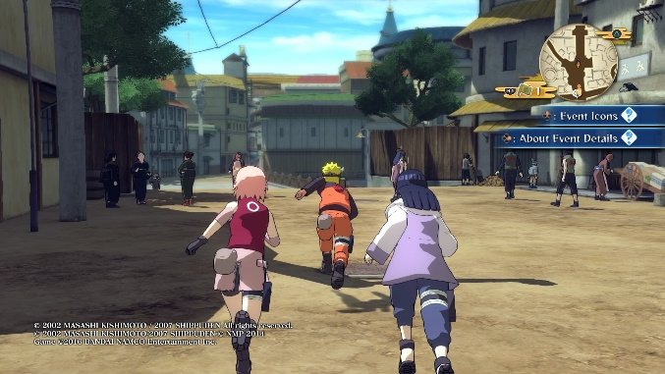

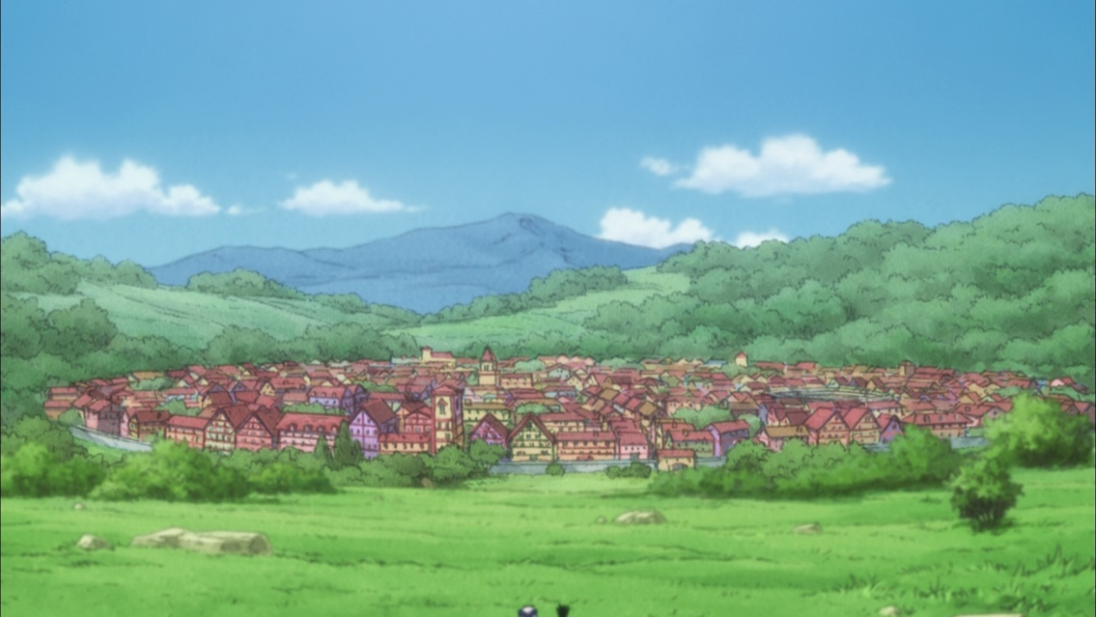The feel of this game takes inspiration from the creators of Naruto Shippuden: Masashi Kishimoto. His style brings all the charesteristics commonly found in shonen style works such as: action, comedy superpowers and combat. The mood of this game is follows advernture despite fact that the game features violence and survival. This means that reenforcing the the mood through artstlyle, warm and colourful pallete and a with a fun and light hearted Ost remiscent of one heard in popular shonens like *Kokuten* by *nico Bellisario and or songs by Yoshihi Hirano*

Example of a village surrounded by forestry

Main view when running with the objective at the bottom left

Anime Style World look

The world design would follow the same artstytle found in Naruto Ninjstorm while staying true to the greed island in the HXH tv series.

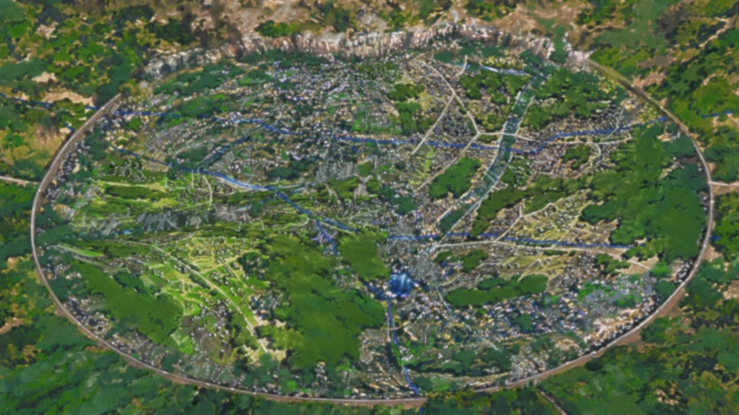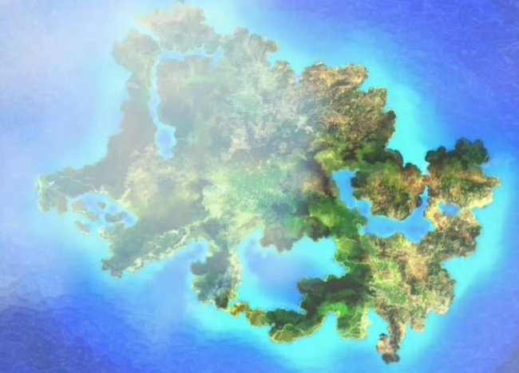

Satellite View of greed island

Birds eye view of a typical village in Naruto

the charchter design of this game varies from traditional japanese kinonos with long draping Haories and wooden zories to gound soilders camo uniforms, martial art Gis to colourful tabbard and a chinese style winkle picker flats

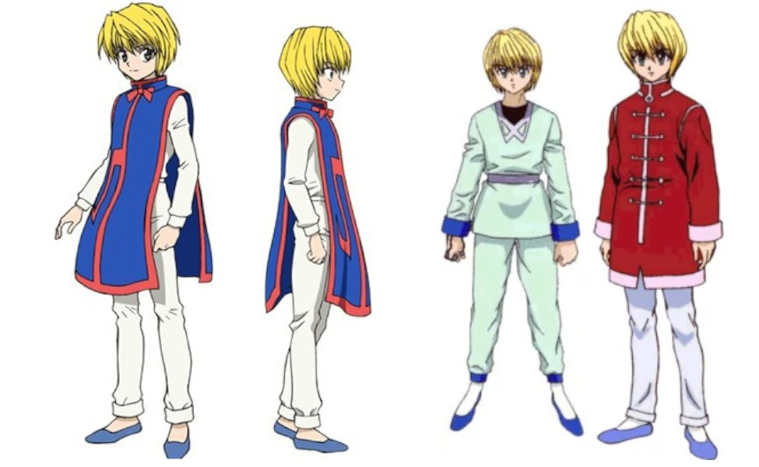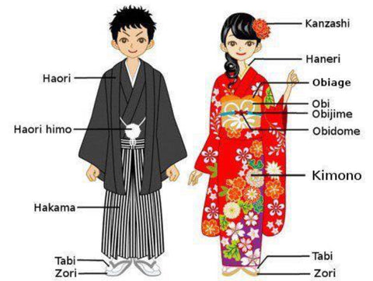

Example of a traditional Japanese kimono

Example a tabard with flat shoes

Menu Layout

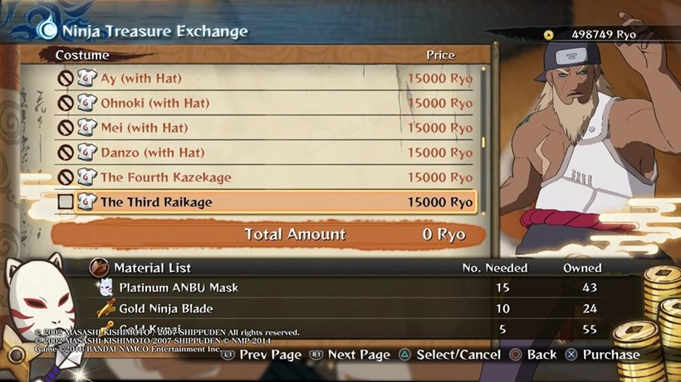The Menue Layout follows the Same Stylistic Japanese shonen philosophy found in the rest of the game. With a 2d menu system featuring the “Manga Tample Font” and manga style icons featured througou

Naruto Ninja-storm 4 Menu

Manga temple font

### Gamasutra - Postmortem: Mimimi's Shadow Tactics: Blades | Ps4 controller, Xbox controller, Ps4Interface

**L2 (hold) : Fire**

**Inventory items**

**L1 : Lock**

**Interact**

Chi Ability Tree Selector

Contols

players use the right stick button to move and long hold at a desired postion to sprint.

players use the left stick to pan the camera in what whate ever 360 degree angle the wish.

Players the D-pad to access their chi ablity tree similar the that the *Arkham knight* series or the *Amazing* *Spider-man* game.

If a player picks up a throwable object such as a rock they can aim and throw using L2 An R2

Players can enter the map using the touch pad and then select any object they wish such as aa medkit or a playing card and use it pressing the X-button.

Since stength is a feature of combat in this game its is players can behind certain objects by pressing the O-button

Some player have the ability to engage in melee combat with oponents so when they enter fight mode by moving neared to an opponent they control type changes to the following.

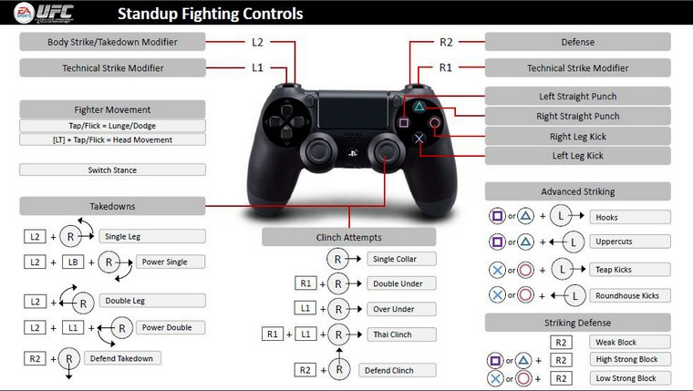

players can also click enter the mini map by entering the inventory menu and selectng the menu tab. There, they can look at the map as long as they wish while in gameplay and mark anywhey they wish for it to show in their main screen.

### startup

as soon as the tutorial section ends a cutscene of the player being transported to the map is shown. They are also spawned at a random location through out the central village. There with just basic chi level and no money or items in the inventory they must then start the game.

### objectives

the objective of this game is to be that last player standing. If you die the game ends for you and you are brought back to the loading screen with nothing. However, player that come in the top 10 are given xp and are allowed to bring back a power card you found in the game to be used the next time they play the game. However, the winner gets 40% of all the XP earned in the game 100,000 yen and is allowed to choose 5 power cards to be used stored and selected when even they play again. If you place lower than 10th you will sadly be left with nothing but a cutscene of how long you survived and how many people you killed.

#### tokens

The following assets are featured in the game

* Island
* Villages and houses
* Food stalls
* NPC Locals
* Player characters
* Chi fog
* Chi objects conjured by players
* Fields
* Trees
* Food
* Med kits
* firearms

### Rules

* Players can scale free run and jump from building rooftops.
* They can also scale trees to hide or use their conjuring powers to grapple around like the scouts in *Attack on Titan.*
* Food stalls hold food which can have various playing cards or the ability to heal a player’s stamina.
* If a player is low on health, they can acquire a heath kit to health them completely.
* Players can also conjure firearms and to shoot and kill each other.
* NPC locals have no use except for the ability to come under the coercion or a manipulator thus using them as zombie to attack opponents or be used and to shroud hide a user tucked inside the group if a user causes a commotion the locals will run and scream alerting other opponents to their location.
* Various chi objects are made by chi users to be used in the manner they were made. Certain players have custom chi abilities that can be bought using XP points.

### Features

* While surviving players must manage to collect power cards by finding in drop cache or taking them from opponents or food stalls.
* They must also balance the risk of entering populated areas in search of more powerful playing cards with remaining gun detected thus making it easier to survive the lower rounds player.
* Players must also balance the risk to moving to far away from the centre of the map as after 5 min the map playable area shrinks killing the player slowly as the longer, they are in the excluded area.
* Players must also manage how high they chose they scale as fall damage is subtracted from the overall health and increases the chance of being detected by locals thus alerting other you a player whereabouts.
* Since there are different types of Chis all with various use applications, a player must view the risks to rewards
* When choosing what their chi type.

### 60 secs of game play

### I’m standing on a tree branch about 1000 feet from the edge of the village with only two minutes to spare until the perimeter collapses onto the onto the perimeter and told us she threw out envelopes me and killing me slowly in turn. I’ve just found and killed a bird creature and acquired the eagle card. This allows me to view the island from a Birdseye view and to control it as I wish. I carefully scale down the tree carefully skilled on the tree and sprint towards the edge of the map. up my advanced chi senses alert me to the presence of an opponent 50 m away. I don’t have time to engage in combat, so I run so I continue to sprint towards the village. Suddenly, I see him he’s too close and he seems to be coming closer and closer and closer towards me. I have no choice but to fight I bring out my firearm and I shoot; I miss him I miss him 2nd time I again aim at his head. Bang!! He’s dead. Okay and I’ll run towards him, and I pick up all his playing cards and any other item he that I find useful and continue to run towards the end of the village there’s only 30 seconds left. I keep running I see a tree so stone I move left and right dodging it in turn

I then look and see my heath bar is decreasing too. All this running isn’t helping. I when I reach safety there is only 10 seconds left. I then take this moment to look at my surroundings. They are clear so I then enter the menu and use a med kit…….